**Secure Socket Layer (SSL)**

Secure Socket Layer (SSL) provides security to the data that is transferred between web browser and server. SSL encrypts the link between a web server and a browser which ensures that all data passed between them remain private and free from attack.

**Secure Socket Layer Protocols:**

* SSL record protocol
* Handshake protocol
* Change-cipher spec protocol
* Alert protocol

**SSL Protocol Stack:**

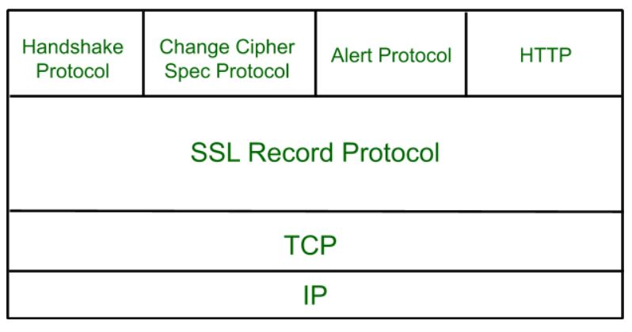

**SSL Record Protocol:**

SSL Record provides two services to SSL connection.

* Confidentiality
* Message Integrity

In the SSL Record Protocol application data is divided into fragments. The fragment is compressed and then encrypted MAC (Message Authentication Code) generated by algorithms like SHA (Secure Hash Protocol) and MD5 (Message Digest) is appended. After that encryption of the data is done and in last SSL header is appended to the data.

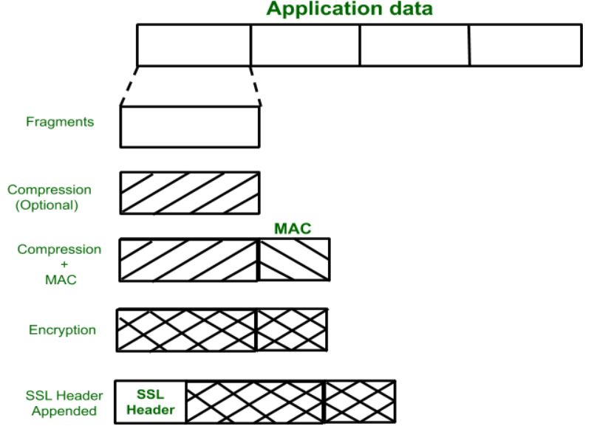

**Handshake Protocol:**

Handshake Protocol is used to establish sessions. This protocol allows the client and server to authenticate each other by sending a series of messages to each other. Handshake protocol uses four phases to complete its cycle.

* **Phase-1:** In Phase-1 both Client and Server send hello-packets to each other. In this IP session, cipher suite and protocol version are exchanged for security purposes.
* **Phase-2:** Server sends his certificate and Server-key-exchange. The server end phase-2 by sending the Server-hello-end packet.
* **Phase-3:** In this phase, Client replies to the server by sending his certificate and Client-exchange-key.
* **Phase-4:** In Phase-4 Change-cipher suite occurs and after this the Handshake Protocol ends.

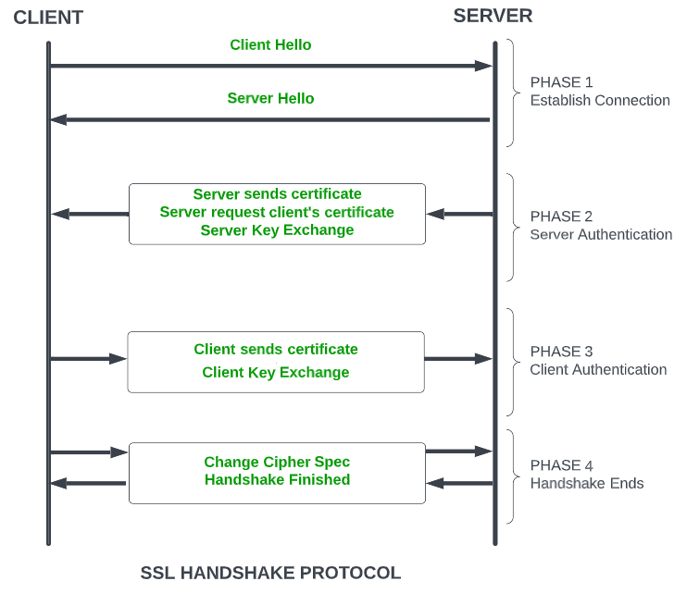

*SSL Handshake Protocol Phases diagrammatic representation*

**Change-cipher Protocol:**

This protocol uses the SSL record protocol. Unless Handshake Protocol is completed, the SSL record Output will be in a pending state. After the handshake protocol, the Pending state is converted into the current state.   
Change-cipher protocol consists of a single message which is 1 byte in length and can have only one value. This protocol’s purpose is to cause the pending state to be copied into the current state.

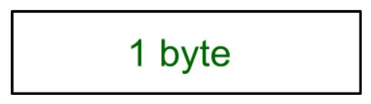

**Alert Protocol:**

This protocol is used to convey SSL-related alerts to the peer entity. Each message in this protocol contains 2 bytes.

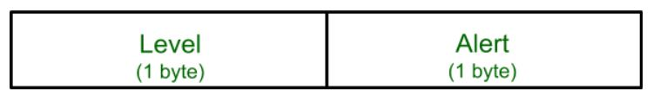

The level is further classified into two parts: 

**Warning (level = 1):**  
This Alert has no impact on the connection between sender and receiver. Some of them are:

**Bad certificate:**When the received certificate is corrupt.  
**No certificate:** When an appropriate certificate is not available.  
**Certificate expired:** When a certificate has expired.  
**Certificate unknown:** When some other unspecified issue arose in processing the certificate, rendering it unacceptable.  
**Close notify**: It notifies that the sender will no longer send any messages in the connection.

**Unsupported certificate:**The type of certificate received is not supported.

**Certificate revoked:**The certificate received is in revocation list.

**Fatal Error (level = 2):**

This Alert breaks the connection between sender and receiver. The connection will be stopped, cannot be resumed but can be restarted. Some of them are :

**Handshake failure:** When the sender is unable to negotiate an acceptable set of security parameters given the options available.  
**Decompression failure**: When the decompression function receives improper input.  
**Illegal parameters:** When a field is out of range or inconsistent with other fields.  
**Bad record MAC:**When an incorrect MAC was received.  
**Unexpected message:**When an inappropriate message is received.

The second byte in the Alert protocol describes the error.

**Salient Features of Secure Socket Layer:**

* The advantage of this approach is that the service can be tailored to the specific needs of the given application.
* Secure Socket Layer was originated by Netscape.
* SSL is designed to make use of TCP to provide reliable end-to-end secure service.
* This is a two-layered protocol.

**Versions of SSL:**

SSL 1 – Never released due to high insecurity.  
SSL 2 – Released in 1995.  
SSL 3 – Released in 1996.  
TLS 1.0 – Released in 1999.  
TLS  1.1 – Released in 2006.  
TLS 1.2 – Released in 2008.  
TLS 1.3 – Released in 2018.

SSL (Secure Sockets Layer) certificate is a digital certificate used to secure and verify the identity of a website or an online service. The certificate is issued by a trusted third-party called a Certificate Authority (CA), who verifies the identity of the website or service before issuing the certificate.

The SSL certificate has several important characteristics that make it a reliable solution for securing online transactions:

1. **Encryption**: The SSL certificate uses encryption algorithms to secure the communication between the website or service and its users. This ensures that the sensitive information, such as login credentials and credit card information, is protected from being intercepted and read by unauthorized parties.
2. **Authentication**: The SSL certificate verifies the identity of the website or service, ensuring that users are communicating with the intended party and not with an impostor. This provides assurance to users that their information is being transmitted to a trusted entity.
3. **Integrity**: The SSL certificate uses message authentication codes (MACs) to detect any tampering with the data during transmission. This ensures that the data being transmitted is not modified in any way, preserving its integrity.
4. **Non-repudiation**: SSL certificates provide non-repudiation of data, meaning that the recipient of the data cannot deny having received it. This is important in situations where the authenticity of the information needs to be established, such as in e-commerce transactions.
5. **Public-key cryptography:** SSL certificates use public-key cryptography for secure key exchange between the client and server. This allows the client and server to securely exchange encryption keys, ensuring that the encrypted information can only be decrypted by the intended recipient.
6. **Session management**: SSL certificates allow for the management of secure sessions, allowing for the resumption of secure sessions after interruption. This helps to reduce the overhead of establishing a new secure connection each time a user accesses a website or service.
7. **Certificates issued by trusted CAs**: SSL certificates are issued by trusted CAs, who are responsible for verifying the identity of the website or service before issuing the certificate. This provides a high level of trust and assurance to users that the website or service they are communicating with is authentic and trustworthy.

In addition to these key characteristics, SSL certificates also come in various levels of validation, including Domain Validation (DV), Organization Validation (OV), and Extended Validation (EV). The level of validation determines the amount of information that is verified by the CA before issuing the certificate, with EV certificates providing the highest level of assurance and trust to users.

Overall, the SSL certificate is an important component of online security, providing encryption, authentication, integrity, non-repudiation, and other key features that ensure the secure and reliable transmission of sensitive information over the internet.